13th January 2021

# Sprint Board

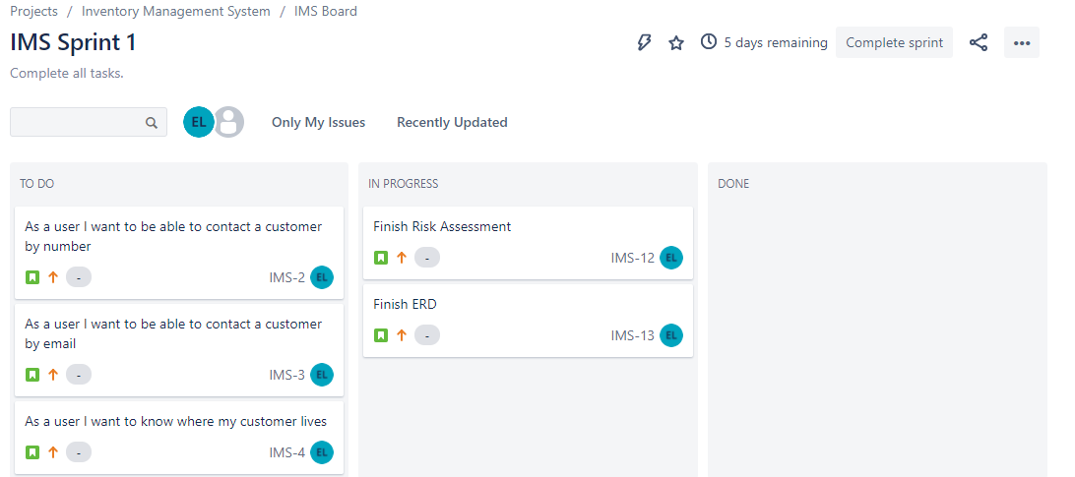

# CodingBat

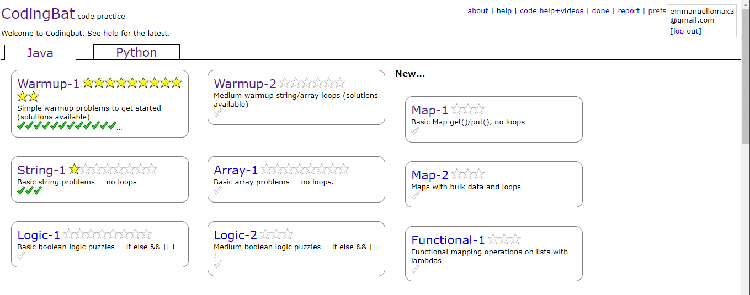

# QA Training

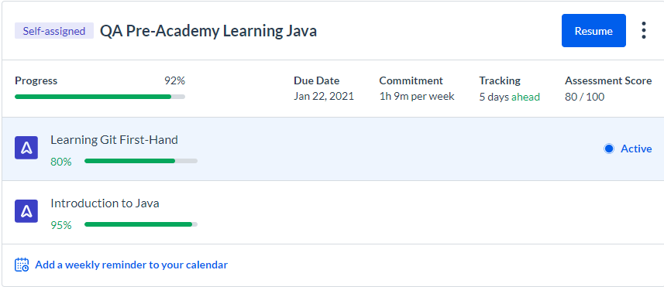

# Current Test Coverage

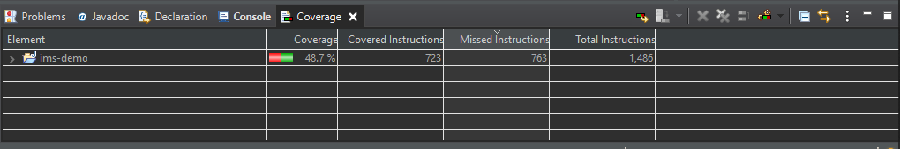

# ERD

No Progress

# UML

No Progress

# SQL HackerRank

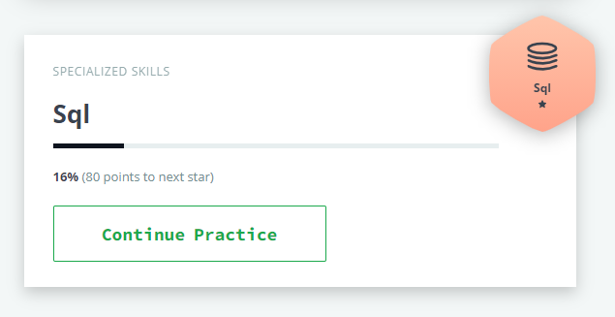

14th January 2021

# Sprint Board

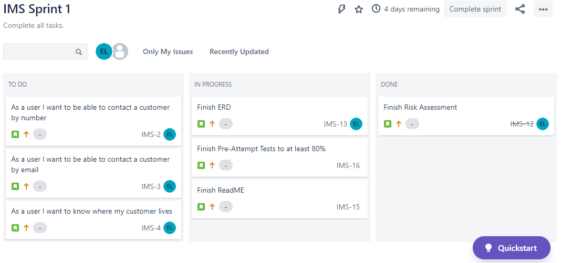

# CodingBat

# 

# QA Training

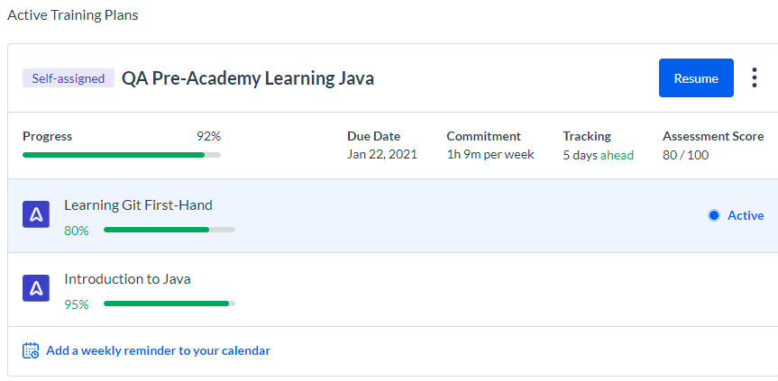

# Current Test Coverage

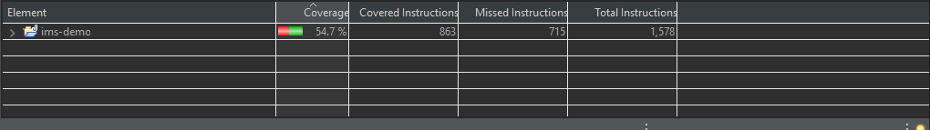

# ERD

No Progress

# UML

No Progress

# SQL Hacker Rank



15th January 2021

# Sprint Board

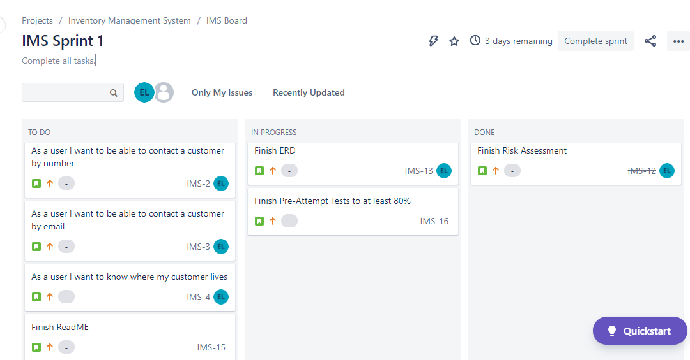

# CodingBat

# 

# QA Training

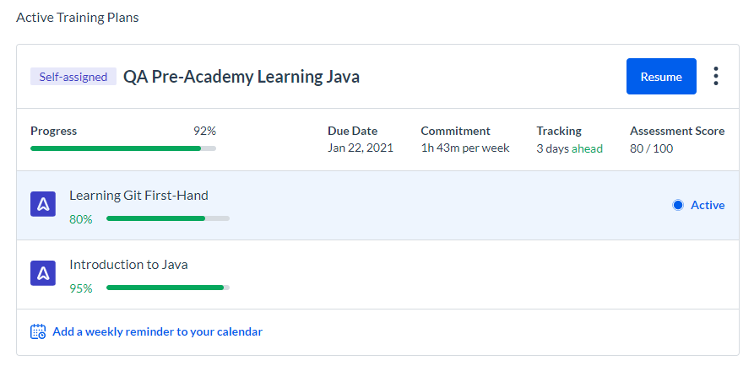

# Current Test Coverage

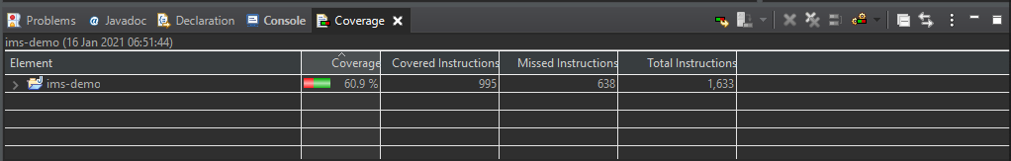

# ERD

No Progress

# UML

No Progress

# SQL Hacker Rank

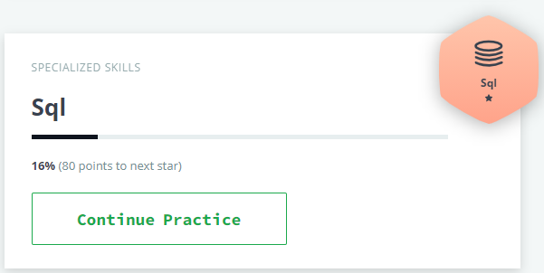

16th January 2021

# Sprint Board



# CodingBat

# 

# QA Training



# Current Test Coverage



# ERD

Started.

# UML

No Progress

# SQL Hacker Rank



17th January 2021

# Sprint Board



# CodingBat

# 

# QA Training

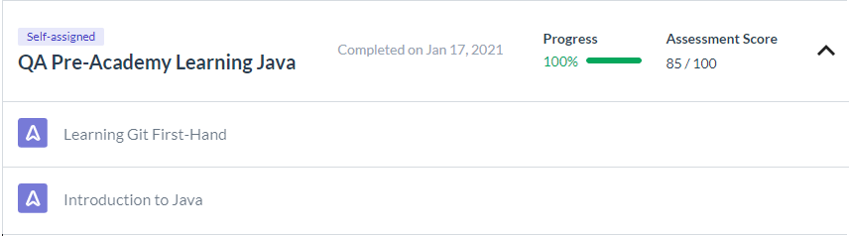

# Current Test Coverage

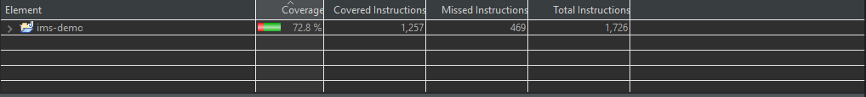

# ERD

Started.

# UML

No Progress

# SQL Hacker Rank



18th January 2021

# Sprint Board

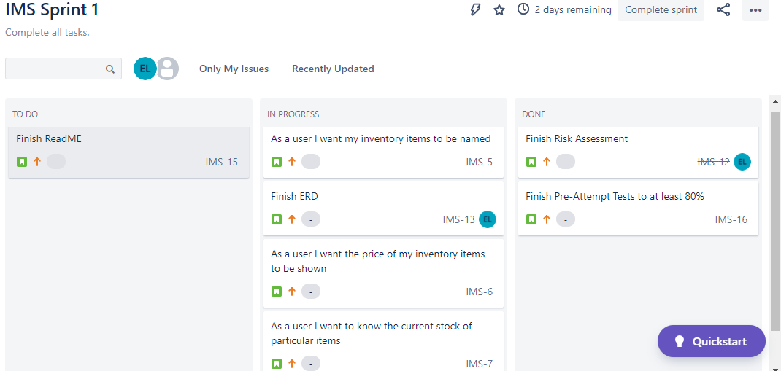

# CodingBat

# 

# QA Training



# Current Test Coverage

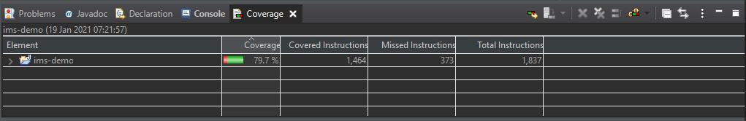

# ERD

Started.

# UML

No Progress

# SQL Hacker Rank



19th January 2020

# Sprint Board



# CodingBat

# 

# QA Training



# Current Test Coverage

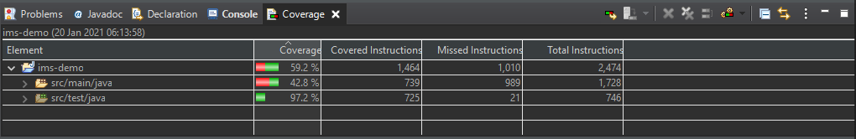

# ERD

# 

# UML

No Progress

# SQL Hacker Rank



20th January 2020

# Sprint Board

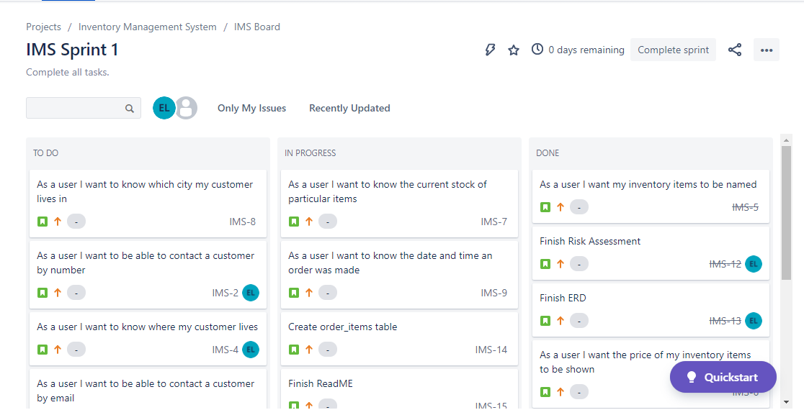

# CodingBat

# 

# QA Training



# Current Test Coverage

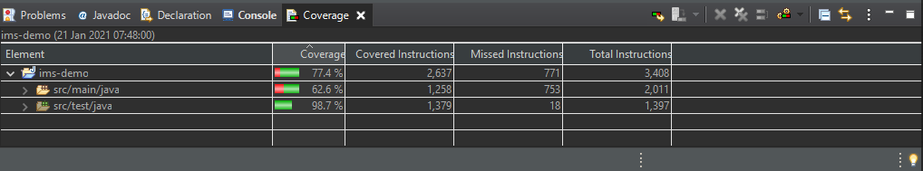

# ERD

# 

# UML

No Progress

# SQL Hacker Rank

